Real-Time Telemetry Analysis and Mission Risk Assessment for Tactical Multirotor ISR UAV Operations
The system is designed to assist mission operators by continuously monitoring the UAV's telemetry and converting complex flight data into meaningful operational insights that improve mission safety and decision-making.
The platform collects and analyses telemetry data generated by the UAV, including GPS location, altitude, speed, IMU readings, battery status, motor performance, ESC parameters, vibration levels, communication signal strength, and flight mode. By combining data from multiple onboard sensors, the system identifies abnormal flight behaviour, detects potential anomalies, evaluates the overall mission risk, and provides timely alerts before these issues develop into mission failures.
A real-time Ground Control Station (GCS) dashboard will present live telemetry, flight status, interactive maps, mission routes, risk levels, anomaly timelines, and system health in a clear and operator-friendly interface. Instead of displaying raw sensor values alone, the platform will generate actionable insights through a risk scoring engine that classifies mission conditions into categories such as Low, Medium, High, and Critical, enabling operators to respond quickly during flight.
To support informed decision-making, the system will include an Operator Decision Support Module that recommends appropriate actions based on the detected anomalies, such as Continue Mission, Reduce Speed, Return-to-Base (RTB), Emergency Landing, or Hardware Inspection. An Explainable Analytics Panel will provide simple, human-readable explanations describing why a particular risk level or alert was generated, making the system transparent and easier to interpret.
The platform will also maintain a mission history database that stores previous flight logs, detected anomalies, mission outcomes, and operator observations. These records will enable post-flight analysis, comparison between normal and abnormal missions, trend identification, and automatic generation of downloadable mission reports in PDF or CSV format.
The system architecture will support multiple UAV profiles, allowing future expansion toward fleet monitoring, predictive maintenance, and integration with different tactical multirotor platforms used in ISR operations.
Overall, the proposed system aims to transform raw UAV telemetry into real-time operational intelligence, enabling safer missions, faster operator response, improved mission reliability, and better situational awareness during Tactical Multirotor ISR UAV operations.

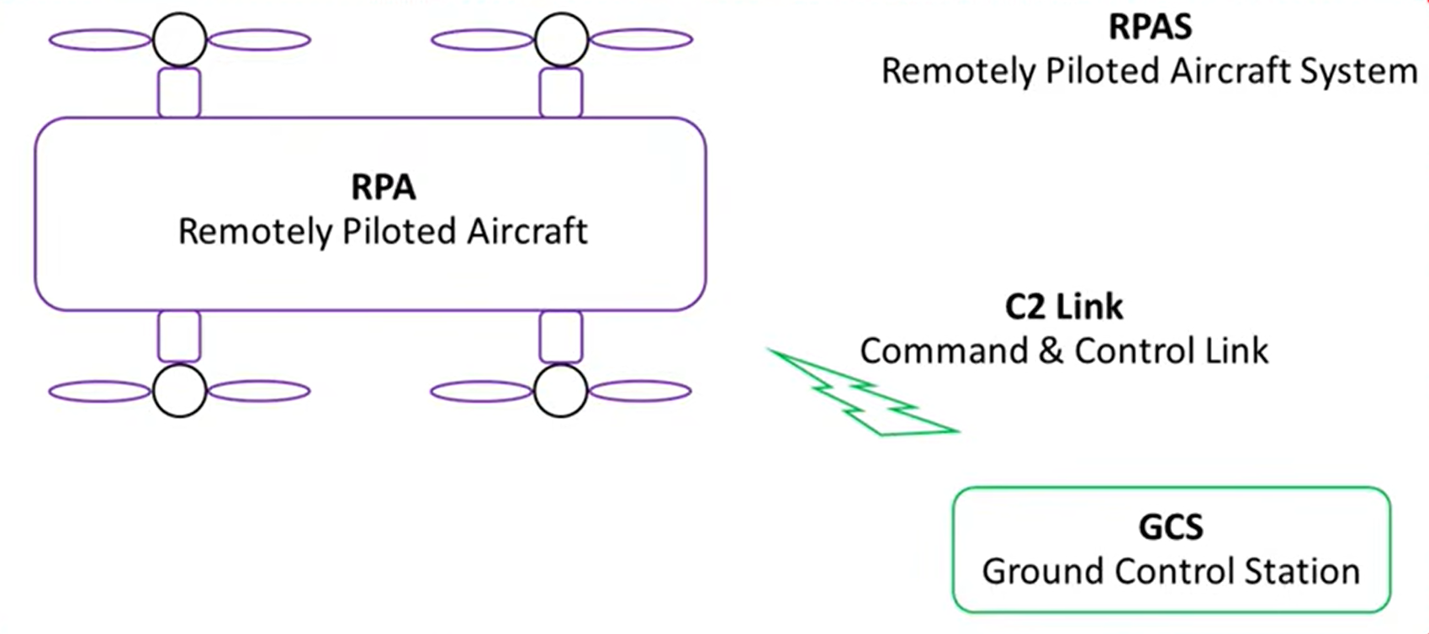
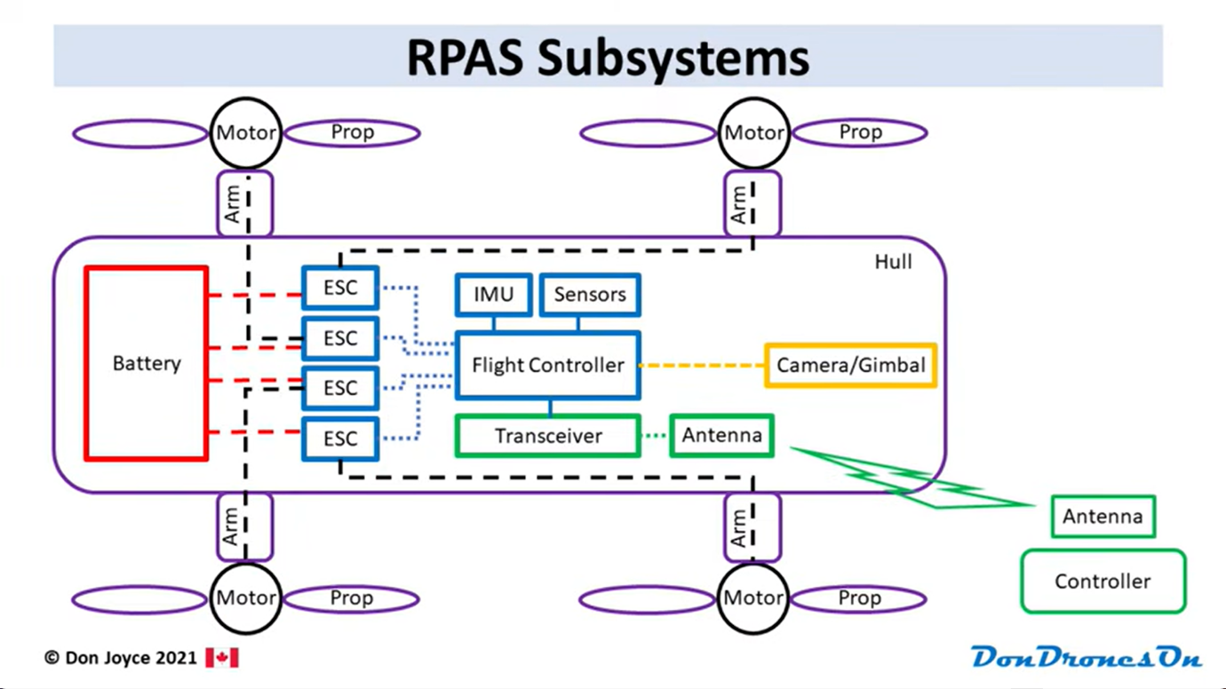

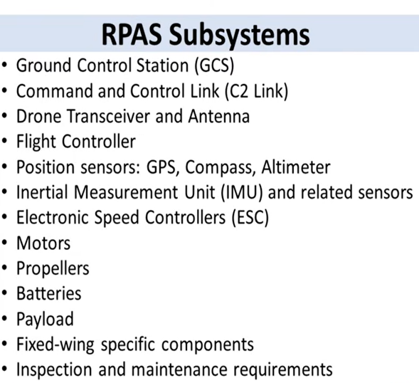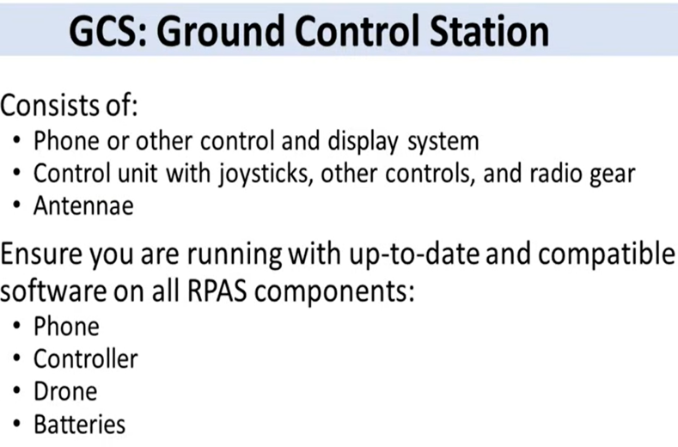

Basics of drone and working
- GCS communicates with RPA using a radio link, Wi-Fi link or DJI OcuSync via C2 link. It is important to maintain a radio line of sight. The signal degrades with obstacles and also by interference from other radio signals such as Wi-Fi, cell phone towers, electromagnetic lines, etc
- RTH return to home autonomous mode is enabled when the signal is lost
- RPA transceiver and antenna receive commands from the GCS, and RPA sends telemetry information to the GCS.
- The flight controller is the brain of RPA, and its main purpose is to implement the pilot's movement by driving command signals to the motors. Also does obstacle avoidance, camera control, battery monitoring, etc. The flight controller needs to know the current position, orientation, velocity, altitude, etc and this information is provided by the IMU, GPS, compass, etc
- The GPS provides precise longitude and latitude. (geomagnetic storms and no sky/ shadow mountain regions can lead to inaccuracy)
- Magnetometer/compass for magnetic north
- Altimeter for altitude of drone using difference in barometric air pressure of current location and take-off location
- IMU provides the flight controller with precise changes in position, altitude, yaw, pitch and roll and sends it 100 times per second. The only issue is that the IMU uses tiny accelerometers and gyroscopes, and even if they are slightly off, the measurements can change drastically. (Recalibration needed)
- The job of the ESC is to deliver the right amount of voltage and current to the motors as directed by the flight controller.
- Motors in the drone are brushless and use an outrunner design. (inner part fixed and outer parts rotate) (counter-rotator: two clockwise and two anti-clockwise)
- Always check the propeller before flight
- Batteries in the drone are Lithium polymer (LiPo) batteries
- Payloads can be cameras, LiDAR, thermal camera, cargo, agricultural fertiliser or pesticides, etc
Movements of Drone: Thrust, Drag, Lift, Gravity, Torque, Pitch, Roll, Yaw, Hover
References:
1) How Drones Work...An Examination of Drone and RC Aircraft Systems
2) How a Quadcopter Works - Flight Mechanics, Components, & Sensors (2)
Types of UAVs: multirotor, fixed-wing, Hybrid VTOL

Ministry of Defence
│
┌──────────────────┴──────────────────┐
│ │
Armed Forces DRDO
(Army • Navy • Air Force) Research & Development
│ │
│ │
│ │
└──────────────────────────────────┘
│
Defence Manufacturing
(HAL • BEL • ideaForge • Adani Defence
• NewSpace • Tata • private industry)
│
│
UAV Platforms
│
│
Ground Control Station (GCS)
│
│
Mission Operators
│
│
Intelligence & Decisions

The telemetry data that we need completely depends on the type of UAV. For our domain, we are collecting telemetry data from multirotor
The missions in which tactical multirotor UAVs are used are
Tactical surveillance
Border surveillance
Reconnaissance
Correcting artillery fire
Artillery support

